CSCI 6307 Foundation of Systems
Assignment #3

Instructor: Dr. Xiang Lian
Due Date: See the course Web page

Student Name: __________________________________________________________

Student ID: __________________________________________________________

Student E-mail: __________________________________________________________

Write your solutions neatly and legibly on your own. Show all necessary steps of your solutions (Partial marks will be given if some steps are correct). If you make any assumptions, please write them down, and justify why those assumptions are reasonable. If you use a source other than the textbook or slides, please cite the reference.

The textbook is:

[A] Computer Organization and Design: the Hardware/Software Interface, 4th Revised Edition, by Patterson and Hennessy, Morgan Kaufmann, 2009.

[O] Modern Operating Systems, 3rd edition, by Andrew S. Tanenbaum, Prentice Hall, 2008.

Assignment Questions (100 points)

1. (10 points) Exercise 5.3.1 of Textbook [A]. (part a only)

2. (20 points) Exercise 5.3.2 of Textbook [A]. (part a only)

3. (20 points) Problem 36 of Chapter 2 in Textbook [O].

4. (30 points) Problem 37 of Chapter 2 in Textbook [O].

5. (20 points) Provide your explanation why the following critical section problem fails:

Proc(int i){
while (true){
Compute;
while (flag[(i+1) mod 2]) ;
flag[i] = true;
// Critical_section;
flag[i] = false;
}
}
shared boolean flag[2];
flag[0] = flag[1] = false;

fork(Proc, 1, 0);
fork(Proc, 1, 1);

Bonus Question (20 points)

Suppose 3 processes p₁, p₂, and p₃ are attempting to use a machine with interrupt-driven I/O concurrently. Assume that each process needs CPU first, and then I/O device; moreover, no two processes can use the I/O device/CPU at the same time.
- p₁: t_{CPU} = 20, t_{IO} = 50
- p₂: t_{CPU} = 30, t_{IO} = 10
- p₃: t_{CPU} = 15, t_{IO} = 35

Please draw the Gantt chart for the process scheduling such that the amount of time required to execute the three processes is the minimum.
20
50 p₁

30
10 p₂

15
35 p₃

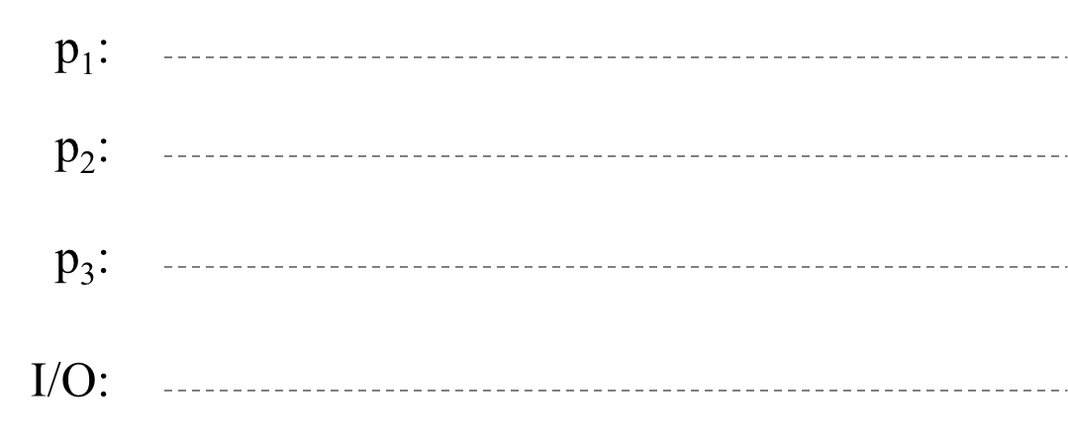

The total time to complete the 3 jobs is given by: ____________________________

Please submit your assignment to the Blackboard.

