MACHINE LEARNING REPORT
FACIAL GENDER RECOGNITION

TEAM MEMBERS:
Javier Suarez Moreno
Patrick Nnaji

INSTRUCTOR:
Dr. Weidong Kuang

ABSTRACT
Machine Learning allows for computers to perform many different and rather complicated tasks. One of those is knows as facial recognition. With the use of facial recognition through machine learning, a computer can determine whether or not a person is the same as another picture, male or female, young or old, etc. In this project, we seek to accomplish specifically being able to recognize a human’s gender through the use of pictures.

Overview
A popular component of computer vision and deep learning revolves around identifying faces. From logging into your phone with your face or searching through surveillance images for a particular suspect. Using facial recognition is an amazing tool for not only information gathering, but for security purposes as well. Distinguishing between a male or female can be distinctly difficult for a computer.

Data and Information
With the help of previously made projects we had access to the following:
- 202,599 number of face images of various celebrities
- 10,177 unique identities,
- Names of identities are not given
- 40 binary attribute annotations per image
- 5 landmark locations
This information will be used by our code in order to train and slowly learn to determine whether the picture is showing a male or a female.

How it was accomplished
Examples of images bellow:
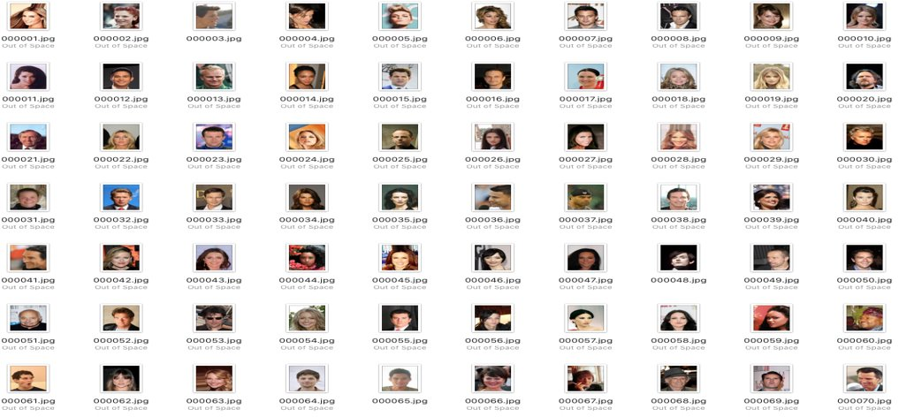
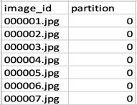
list_eval_partition.csv:
Used three different training sets:
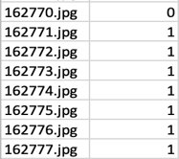
TRAINING SET------ Images 1 – 162770(0)​
TESTING SET -------Images 162771 to 182637(1)​
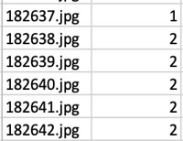
TESTING SET -------Images 182638 to 202599(2)​

list_bbox_celeba.csv:​
Containing the following information:
- "x_1" and "y_1" represent the upper left point coordinate of bounding box.​
- "width" and "height" represent the width and height of bounding box​
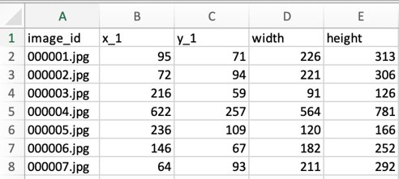

list_landmarks_align_celeba.csv:​
Making adjustments to landmarks such as:
- There are 5 landmarks:​
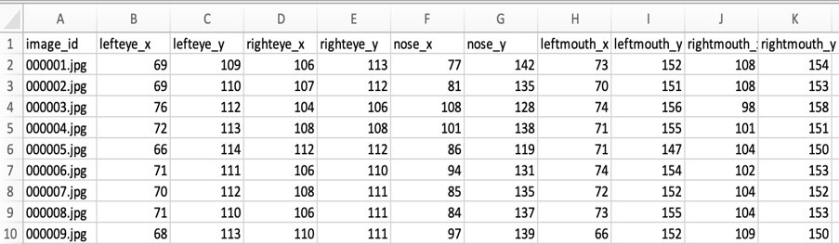
- Left eye​
- Right eye​
- Nose​
- Left mouth​
- Right mouth
Libraries:
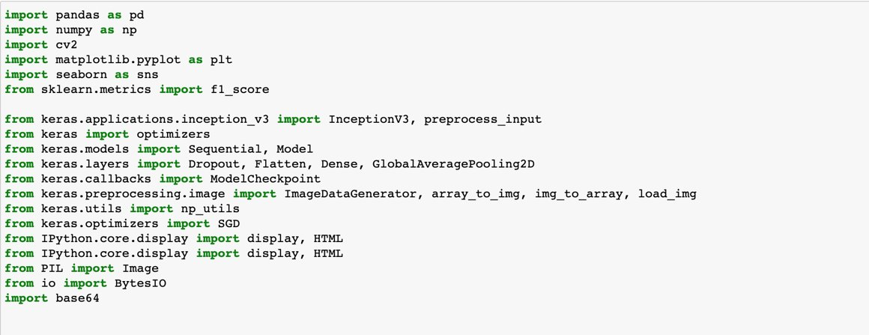

Results
LOSS FUNCTION GRAPH​
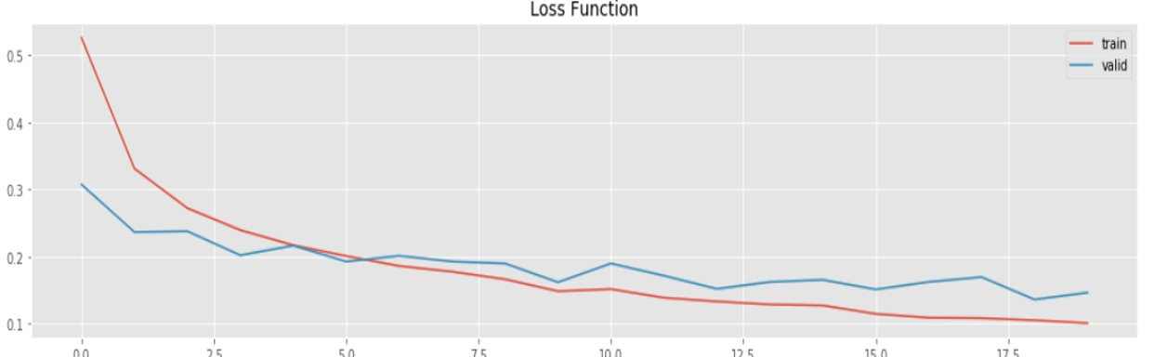

ACCURACY PLOT​
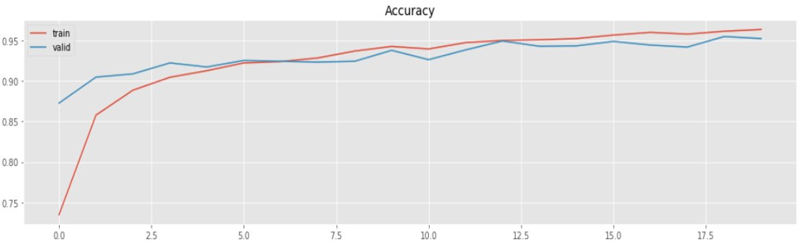
Overall Results:
The accuracy on the test set is 93.6000%
For almost all the test set, the network was able to differentiate between a male and a female celebrity. However, in some cases the network prediction failed.
- Pictures were able to be described as containing a male or a female for the most part
- The program, however, took almost 8 hours to train and run
- This made it a problem to deal with, since making small changes would require hours in order to determine whether the change was positive.

Works Cited
- https://www.kaggle.com/bmarcos/image-recognition-gender-detection-inceptionv3
- https://www.kaggle.com/jessicali9530/celeba-dataset
- https://www.kaggle.com/madmaxliu/inceptionv3

