Final Project Report
Face Detection

TEAM MEMBERS:
Jose Elizondo
Sergio Tamez

Instructor: Dr. Kuang
Machine Learning

Figure List
Figure 5.1 Python Code 3
Figure 6.1 Single Face Detection 4
Figure 6.2 Two Face Detection 4

Table of Contents
Figure List....................................................................................................................................... i
1. Introduction................................................................................................................................. 1
2. Machine Learning History.......................................................................................................... 1
3. Machine Learning Approaches................................................................................................... 2
4. Goals............................................................................................................................................3
5. Python Code.................................................................................................................................3
6. Conclusion.................................................................................................................................. 4
7. References................................................................................................................................... 5

1. Introduction
The findings of the project are impressive because the software is in OpenCV libraries. Inside OpenCV libraries, we are going to be using facial recognition. Facial recognition is being used in everyday daily lives. We thought that it would be a great experience to acknowledge and to challenge ourselves. Since this was part of our research of our senior design project, we wanted to show bits of pieces of how we approached facial recognition while using OpenCV libraries. In our senior design project, we are going to apply reinforcement learning; so, the robotic hand can acknowledge the user’s strategy. However, in this machine learning project, we wanted facial recognition to detect a face on camera.
2. Machine Learning History
Machine learning is a study of concepts and computer algorithms to improve experiences. Machine learning is known as a branch of artificial intelligence. Also, machine learning algorithms construct models based upon samples of data which is also known as training data; in order to predict or make decisions without being programmed to do so. However, machine learning algorithms are being used in a wide umbrella of varieties of software applications, for example, email filtering and computer visions; which is difficult to develop in a conventional program to perform its tasks.
The branch of machine learning is related to computational statistics that focuses on conducting predictions using computers; but machine learning is not statistical learning. There is a study of mathematical optimizations which delivers methods, theory, and applications that have their own domains to the field of machine learning. Another related field of study is Data Mining, which focuses on expanding in data analysis through unsupervised learning.
3. Machine Learning Approaches
Supervised learning constructs a mathematical model of sets of data which contains both inputs and desired outputs. The data known as training data which consists of sets of training examples. Each training example has more than one input and output, also called supervisory signal. Also, in a mathematical model, each train example is characterized by an array or a vector, a feature vector, and a matrix. Through optimization of a function, supervised learning algorithms start to understand a function that's being used to see the predicted outputs from the new inputs. There’s an optimal function which allows the algorithm to dictate the outputs for inputs that were not in the training data. It’s an algorithm which improves the accuracy of the outputs over time.
Unsupervised learning algorithms take hold of sets of data inputs and discover structure in data and data points. Algorithms learns the data that have not been labelled or categorized. Instead of answering to feedback, unsupervised learning algorithms pinpoint the commonalities inside the data. The application of unsupervised learning is the field of density estimation of statistics which is known as probability density function.
Reinforcement learning is a part of machine learning that is troubling because it's how software agents take actions. Generally, this field of study has many other disciplines, such as game theory, control theory, operations research, information theory, and simulation-based theory. Machine learning environments are typically characterized as Markov decision processes. There are many reinforcement learning algorithms that are being utilized in dynamic programming techniques. Reinforcement learning algorithms do not have the knowledge of the mathematical model of MDP. Reinforcement learning algorithms are utilized in autonomous automobiles or even learning how to play a game against a human opponent.
4. Goals
In Senior Design, our capstone is about a robotic arm that learns to play rock paper scissors. We want our project to use facial recognition software, so it knows who it is playing against. We are taking advantage of this early this semester by starting our research on face detection. Face detection is only supposed to detect a face. It is not yet facial recognition just yet.
Running the software will launch my webcam and the video from it. Using a loop to test each frame to detect the face. It should create a blue block outline around the face based on a library of HAAR cascades with OpenCV. We imported an xml HAAR file that already has a library of faces it learned. In theory it should capture any face the software runs.

5. Python Code

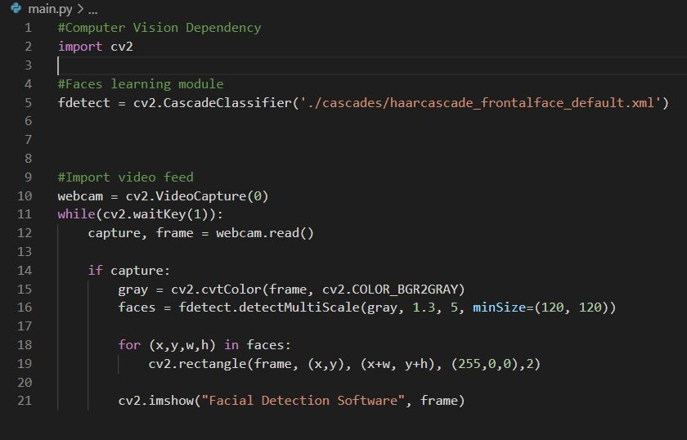
Figure 5.1: Python Code

6. Conclusion
In conclusion facial recognition is really amazing to work with. However, the research was intense because of finding out how we are approaching this. Facial recognition is going to be amazing to work with; once we apply this software to our intelligent robotic arm. We are sure that it is going to be difficult once the robotic arm is interacting and playing against the user. Once the robotic arm learns to play against the user, our senior design project will be a finished product. The results of facial recognition are figure 6.1 and figure 6.2.
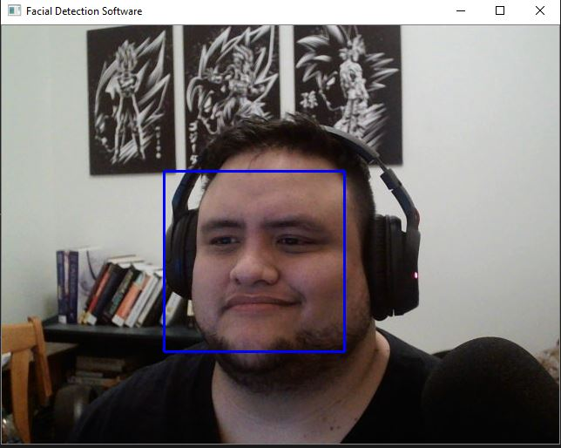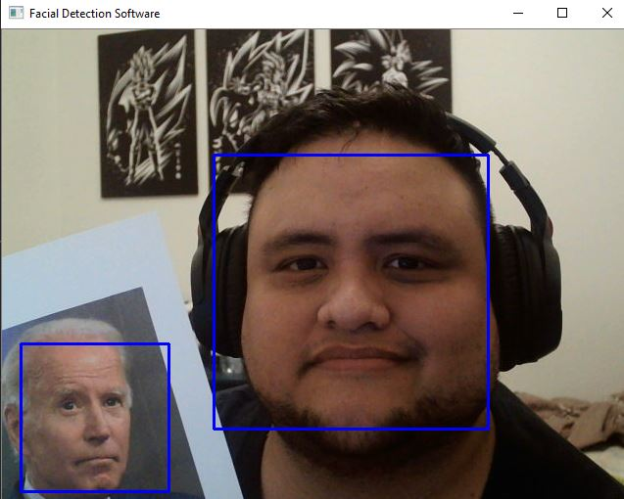
Figure 6.1: Single Face Detection Figure 6.2: Two Face Detection

7. References

[1] “Detecting and Recognizing Faces.” Learning OpenCV4 with Python, 12th January 2020, https://www.amazon.com/gp/product/1789531616/

