FACIAL RECOGNITION PROJECT
SALVADOR LEON LOPEZ ID: 20432704

Simple project for facial recognition based on a database of known faces. Requirements for the project are cmake, open cv, face_recognition, numpy and dlib. Also, only png and jpg images are allowed to be compatible with the libraries.

How does it work? Given an input of known faces they get encoded and listed as a directory to serve as our known faces which will be the options to be “recognized” on a different image. Each mugshot images is named with the name of the person whom the face corresponds to.

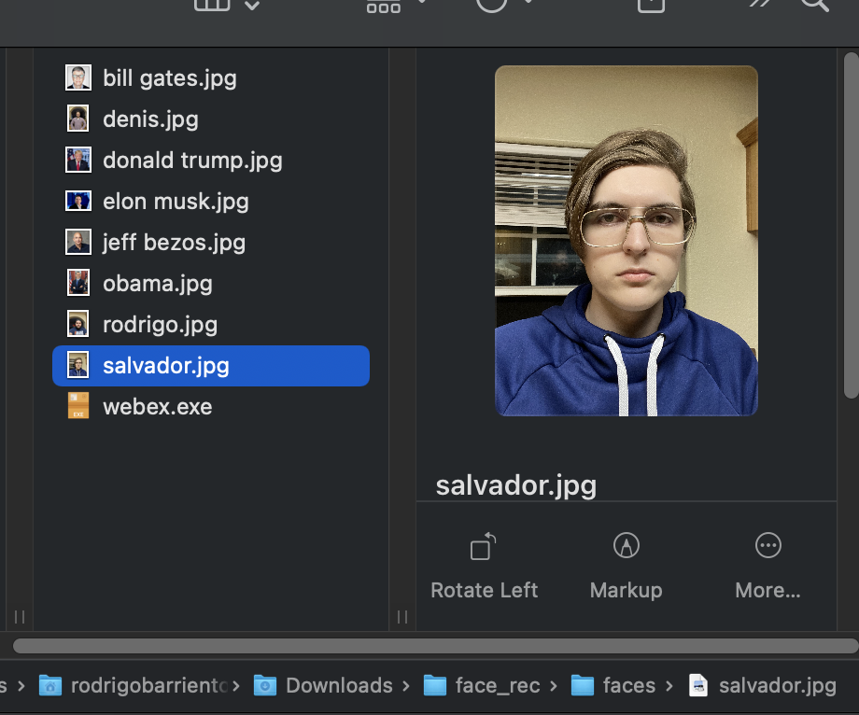

Upon input of a different image with one or multiple faces on it, it gets encoded and each face is the compared with the directory previously created. A function called best match lets us know which face is the closest to the one on the unknown image and it displays the name and the image now has that face recognized. This process happens for each face on the image.

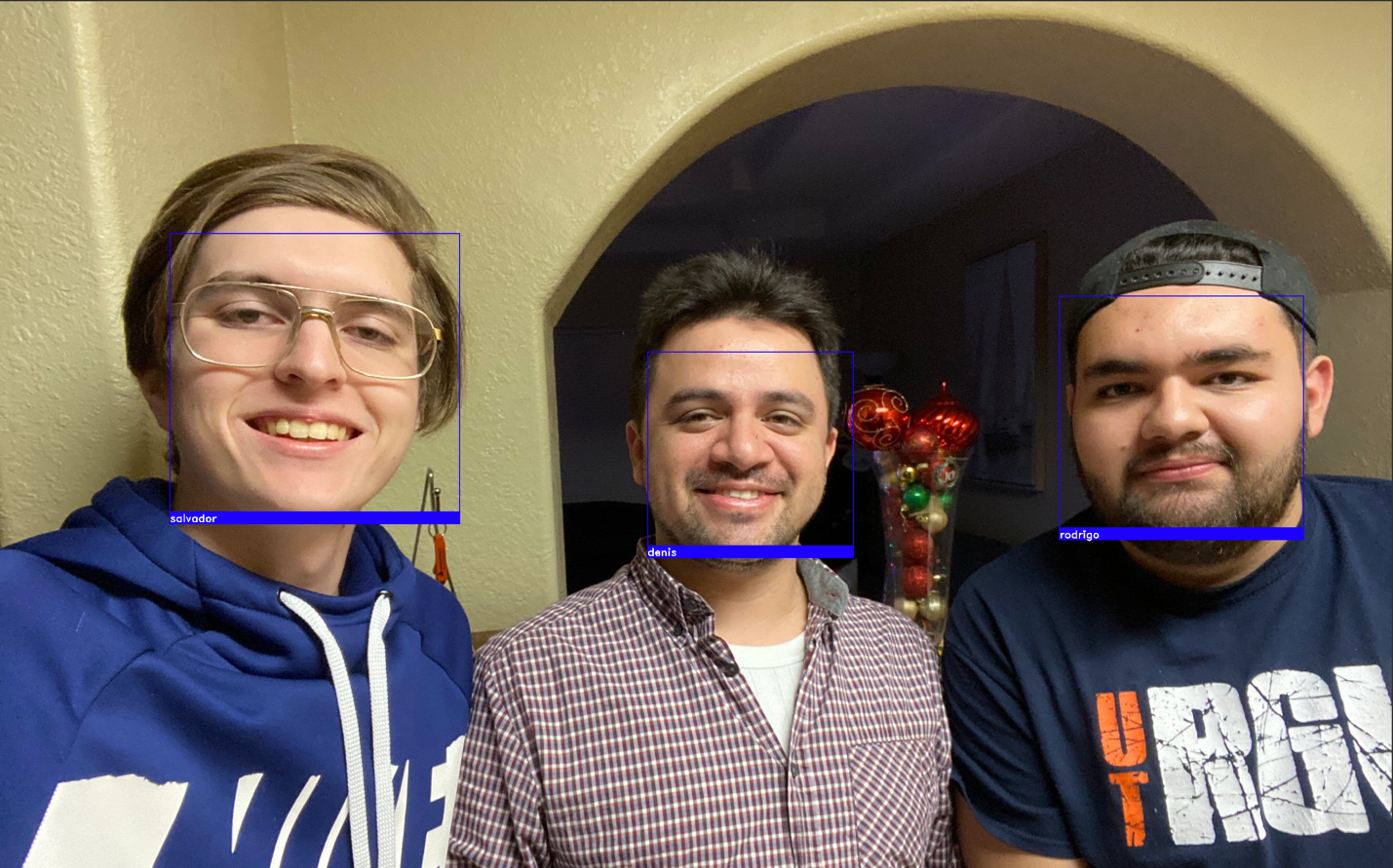

Successfully matched known faces into a different image. As the samples are minimal, the program may relate faces when people look alike and incorrectly label people. If there is no best match the face will pop out as “Unknown”.

Code:
import face_recognition as fr
import os
import cv2
import face_recognition
import numpy as np
from time import sleep

#Get encoded faces to recognize
def get_encoded_faces():
encoded = {}
for dirpath, dnames, fnames in os.walk("./faces"):
for picture in fnames:
if picture.endswith(".jpg") or picture.endswith(".png") or picture.endswith(".jpeg"):
face = fr.load_image_file("faces/" + picture)
print(picture)
encoding = fr.face_encodings(face)[0]
encoded[picture.split(".")[0]] = encoding
return encoded

def unknown_image_encoded(img):
#Encode Face
face = fr.load_image_file("faces/" + img)
encoding = fr.face_encodings(face)[0]
return encoding

def classify_face(im):
#Check if a face in the image is already known and clasify them
faces = get_encoded_faces()
faces_encoded = list(faces.values())
known_face_names = list(faces.keys())

img = cv2.imread(im, 1)

face_locations = face_recognition.face_locations(img)
unknown_face_encodings = face_recognition.face_encodings(img, face_locations)

face_names = []
for face_encoding in unknown_face_encodings:
matches = face_recognition.compare_faces(faces_encoded, face_encoding)
name = "Unknown"

face_distances = face_recognition.face_distance(faces_encoded, face_encoding)
best_match_index = np.argmin(face_distances)
if matches[best_match_index]:
name = known_face_names[best_match_index]

face_names.append(name)

for (top, right, bottom, left), name in zip(face_locations, face_names):
cv2.rectangle(img, (left-20, top-20), (right+20, bottom+20), (255, 0, 0), 2)
cv2.rectangle(img, (left-20, bottom -15), (right+20, bottom+20), (255, 0, 0), cv2.FILLED)
font = cv2.FONT_HERSHEY_DUPLEX
cv2.putText(img, name, (left -20, bottom + 15), font, 1.0, (255, 255, 255), 2)

# Display the resulting image
while True:
cv2.imshow('Video', img)
if cv2.waitKey(1) & 0xFF == ord('q'):
return face_names

print(classify_face("test.jpg"))
print(classify_face("test2.jpg"))
print(classify_face("test3.jpg"))

