- Install pytorch
Reference:
https://pytorch-nlp-tutorial-ny2018.readthedocs.io/en/latest/environment_setup.html
Steps:
- Run Anaconda prompt
- Create environment
(base) C:\Users\weido>conda create -n mypytorch python=3.6
WARNING conda.base.context:use_only_tar_bz2(632): Conda is constrained to only using the old .tar.bz2 file format because you have conda-build installed, and it is <3.18.3. Update or remove conda-build to get smaller downloads and faster extractions.
Collecting package metadata (repodata.json): done
Solving environment: done

## Package Plan ##

environment location: C:\Users\weido\AppData\Local\Continuum\anaconda3\envs\mypytorch

added / updated specs:
- python=3.6

The following packages will be downloaded:

package | build
---------------------------|-----------------
certifi-2019.11.28 | py36_0 157 KB
pip-20.0.2 | py36_1 1.9 MB
python-3.6.10 | h9f7ef89_0 20.3 MB
setuptools-45.1.0 | py36_0 691 KB
sqlite-3.30.1 | he774522_0 962 KB
vs2015_runtime-14.16.27012 | hf0eaf9b_1 2.4 MB
wheel-0.34.1 | py36_0 67 KB
------------------------------------------------------------
Total: 26.5 MB

The following NEW packages will be INSTALLED:

certifi pkgs/main/win-64::certifi-2019.11.28-py36_0
pip pkgs/main/win-64::pip-20.0.2-py36_1
python pkgs/main/win-64::python-3.6.10-h9f7ef89_0
setuptools pkgs/main/win-64::setuptools-45.1.0-py36_0
sqlite pkgs/main/win-64::sqlite-3.30.1-he774522_0
vc pkgs/main/win-64::vc-14.1-h0510ff6_4
vs2015_runtime pkgs/main/win-64::vs2015_runtime-14.16.27012-hf0eaf9b_1
wheel pkgs/main/win-64::wheel-0.34.1-py36_0
wincertstore pkgs/main/win-64::wincertstore-0.2-py36h7fe50ca_0

Proceed ([y]/n)? y

Downloading and Extracting Packages
wheel-0.34.1 | 67 KB | ############################################################################ | 100%
vs2015_runtime-14.16 | 2.4 MB | ############################################################################ | 100%
sqlite-3.30.1 | 962 KB | ############################################################################ | 100%
setuptools-45.1.0 | 691 KB | ############################################################################ | 100%
certifi-2019.11.28 | 157 KB | ############################################################################ | 100%
python-3.6.10 | 20.3 MB | ############################################################################ | 100%
pip-20.0.2 | 1.9 MB | ############################################################################ | 100%
Preparing transaction: done
Verifying transaction: done
Executing transaction: done
#
# To activate this environment, use
#
# $ conda activate mypytorch
#
# To deactivate an active environment, use
#
# $ conda deactivate

- Activate environment
(base) C:\Users\weido>conda activate mypytorch

C:\Users\weido>set "KERAS_BACKEND="
(mypytorch) C:\Users\weido>

- Install ipython, jupyter, ipykernel
(mypytorch) C:\Users\weido>conda install ipython
(mypytorch) C:\Users\weido>conda install jupyter

(mypytorch) C:\Users\weido>python -m ipykernel install --user --name mypytorch

Reference:
https://medium.com/@bryant.kou/how-to-install-pytorch-on-windows-step-by-step-cc4d004adb2a

- Install pytorch
(mypytorch) C:\Users\weido>conda install pytorch -c pytorch

(mypytorch) C:\Users\weido>conda list pytorch
# packages in environment at C:\Users\weido\AppData\Local\Continuum\anaconda3\envs\mypytorch:
#
# Name Version Build Channel
pytorch 1.4.0 py3.6_cuda101_cudnn7_0 pytorch

- Install other packages: sklearn, scipy, pandas, matplotlib, torchvision
(mypytorch) C:\Users\weido>conda install scikit-learn
(mypytorch) C:\Users\weido>conda install pandas
(mypytorch) C:\Users\weido>conda install matplotlib
(mypytorch) C:\Users\weido>conda install statsmodels
(mypytorch) C:\Users\weido>conda install seaborn
(mypytorch) C:\Users\weido>conda install pytorch=1.4.0 torchvision -c pytorch

(Later, install skimage)
(mypytorch) C:\Users\weido>conda install -c conda-forge scikit-image

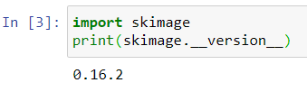

- Testing
Run jupyter notebook from the command prompt or start bar

(mypytorch) C:\Users\weido>jupyter notebook

or
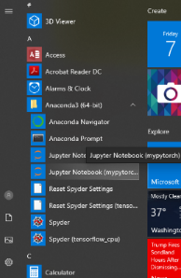
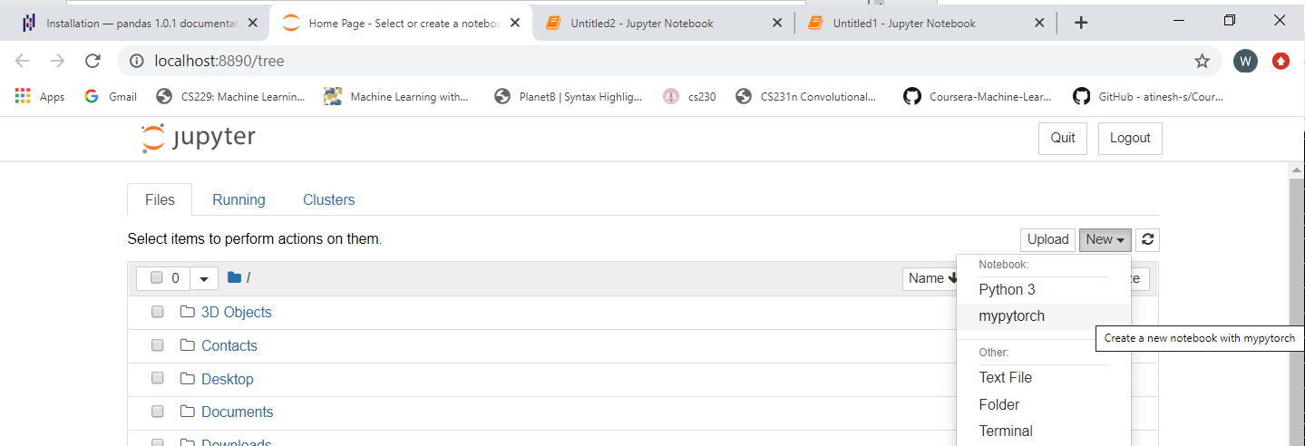
Select New: mypytorch

