CSCI 6345

In class Assignment 9

4/9/2020

Using the following diagram, create a routing table for R1, R2 and R3

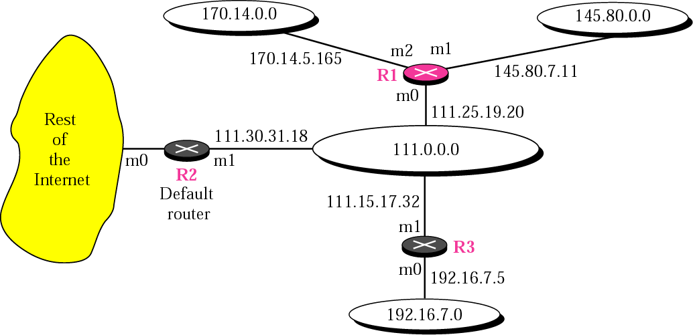

Given a CIDR address, find the first usable address and netmask.

Given a classfull network address and organizational requirements, make subnets and subnet masks. Example question: A class C address was given to your company. You have 4 departments with approximately equal number of computers and printers with a total of 100 devices requiring IP addresses. Make a subnet and explain your reasoning.

UTRGV is given a class B IP address: 129.113.0.0. The computer science department requires 312 IP addresses. Create a CIDR address to hand to the computer science department. What would be subnet mask for a classfull address?