In class exercise 8

1. A subnet mask in class B has 19 1s. How many subnets does it define? Show work.
2. Given the IP address of 201.14.78.65 and subnet mask of 255.255.255.224, what is the first IP of this subnet? Show work.
3. One of the addresses given to an organization is 12.2.2.126/28. What is the first and last address of this block?
4. How many addresses are available in 12.2.2.7/30?

3. An HLEN value of decimal 10 means what?

4. If the fragment offset has a value of 100 what is the first byte number of this datagram?

5. What is needed to determine the number of the last byte of a fragment?

6. A packet with 4000 bytes needs to be sent. Fragmentation is allowed. It first passes through a network with a MTU of 1400, later it travels through a network with a MTU of 800. Show the fragments formed in the first network, and show the second fragment from this one being fragmented as it travels through the second network. I am looking specifically for Header length, Total Length, fragmentation flags, and fragment offset fields. Also show the byte numbers in each fragment. Also, explain how reassembly takes place.

7. Use this diagram

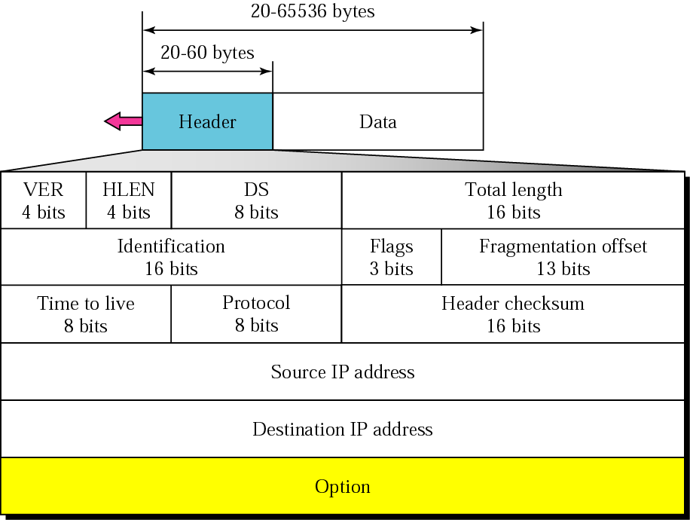

a. If the HLEN has a value of 7, how many option bytes are present?

b. An IP fragment arrived with fragmentation offset of 0 and M bit of 0. Is this a fragment, if it is, is it the first, middle or last fragment?

c. An IP datagram arrived with the following in the header (HEX - I ADDED THE SPACES FOR CLARITY): 45 00 00 54 00 03 00 00 20 06 00 00 7C 4E 03 02 B4 0E 0F 02. Are there any options? How many?