**[Balance sheet](http://www.accountingtools.com/definition-balance-sheet).** Shows the entity's assets, liabilities, and stockholders' equity. Assets are items owned by the entity, bank balances, stocks, bonds, buildings, automobiles, tools, etc. Liabilities are the items owed by the entity, such as accounts payable, taxes, mortgages, credit card debts, etc.

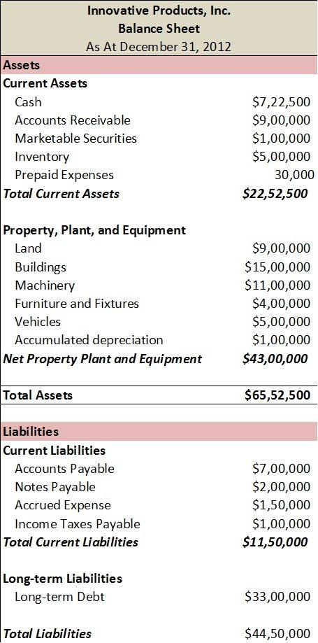

**Total Owners Equity $2,102,500**

**Total $65,52,500**

[**Income statemen***t*](http://www.accountingtools.com/definition-income-statement). Shows the results of the entity's operations and financial activities for the reporting period. It includes revenues, expenses, gains, and losses. An income statement is the most common financial statement and shows a company's revenue; total expenses, including noncash accounting such as depreciation. An income statement is used to determine the financial performance of a company, specifically how much revenue it made, how much expenses it paid, and the resulting profit or loss from the revenue and expenses. The income statement is designed to show how much profit your business made during the specific reporting period covered by the statement.

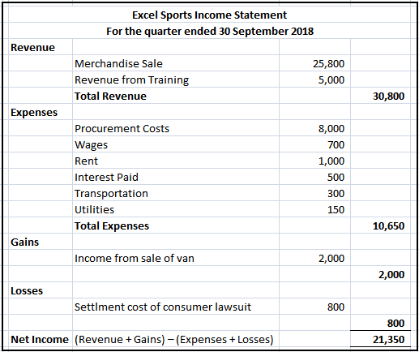

[**Statement of cash flows**](http://www.accountingtools.com/definition-cash-flows)**.** Shows changes in the entity's cash flows during the reporting period. Income statement my include items not collected or items not paid. The cash from operating activities can be compared to a company’s net income. If the cash brought in from operating activities are higher than the net income, then earnings can be considered as “high quality.” On the other hand it is reverse, then it might be accounting manipulations. If a company generates more cash than it spends, the extra cash can be used to pay dividends or buy back stocks.  Unlike an income statement, the cash flow statement's purpose is to show how much cash your business generates and spends.

