Java Script
Assignment #4
CSCI 6314 (e-Commerce)
Dr. Abraham

Due: 10/7/2018

Purpose of this program is to thoroughly familiarize students with arrays and string handling. Furthermore, students will learn array based stack.

Write a program to solve a mathematical problem given in postfix notation. Postfix notation is a notation for writing arithmetic expressions in which the operands appear before their operators. The advantage is that there are no precedence rules and parentheses are never needed. We evaluate the expression by scanning from left to right. Consider the problem 6 2 / 5 +. Look for the first operator beginning from left. The division operator is applied to the immediate previous operands. The divisor would be the later one, in this case 2. Now the problem has been reduced to 3 5 +. Continue processing until the end of the problem statement.
Here are some problems with results.
postfix expression result
* this description and the samples are
4 5 7 2 + - * -16 taken from Nell Dale's Book.
3 4 + 2 * 7 / 2
5 7 + 6 2 - * 48

Technical notes: The program should accept real numbers as well as integers. You need to enter the problem as a string. The string should be parsed character at a time. Determine if the characters make operands or operators. If operands, convert them to numbers and push into a stack. If an operator, pop and do the required operation. Show all pushes and pops. Write a warning message if there is an error in the problem. Give the result at the end. Here is an example of a program run.
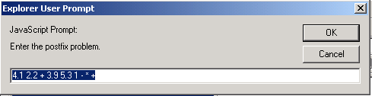

Postfix Problem: 4.1 2.2 + 3.9 5.3 1 - * +
pushed 4.1
pushed 2.2
popped 2.2 4.1 +
pushed 6.3
pushed 3.9
pushed 5.3
pushed 1
popped 1 5.3 -
pushed 4.3
popped 4.3 3.9 *
pushed 16.77
popped 16.77 6.3 +
pushed 23.07
The result of the operation is--> 23.07

