Assignment 2
CSCI 6314
Dr. Abraham
Java Script

Due date: 9/19/16
Write a javaScript program to calculate number of quarter, dime, nickel and penny rolls yielded given an input in whole dollars. See program run below:
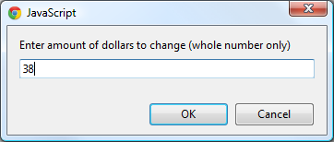

Amount Entered: $38
Quarter Rolls: 3
Dime Rolls: 1
Nickel Rolls: 1
Penny Rolls: 2

