**Group 8 / XML Assignment**

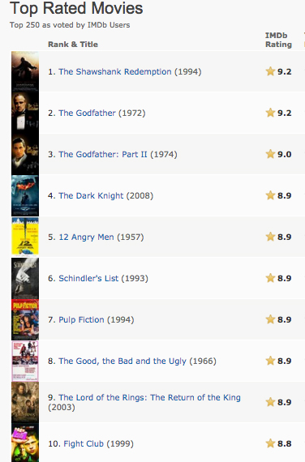

1. Represent the tree structure, and then write an XML document containing the following information: top rated movies, movie, rank, title, year, IMDb rating.
2. Email homework to [**magda.guzmancisneros01@utrgv.edu**](mailto:magda.guzmancisneros01@utrgv.edu)as an attachment with the following as the subject**: G8 XML last_name first_name.** Due date: November 29, 11:59 pm.