**CSCI 6303**

**Architecture**

**Assignment 6**

**Dr. Abraham**

Explain the function of each of the following registers including the flow of bits (data/instruction) in a logical order:

PC- Program Counter

MBR- Memory Buffer Register

MAR- Memory Address Register

ALU- Arithmetic Logic Unit

IR- Instruction Register

AC – Accumulator Register

General Purpose Registers.

We have an imaginary computer that can have up to 16 opcodes and operands that can range from 0 to 212. Operands can be immediate values or refer to memory locations. You can design your own instruction set using the following as a guideline.

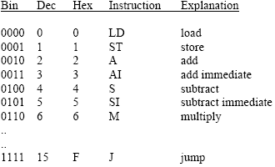

Write a program to multiply two numbers and store the result. Using diagrams show what happens in each CPU cycle.