LAB ASSIGNMENT 1

Install Virtual Machine

Dr. Abraham

Due: Check blackboard for due dates

**For all assignments, this and future, please submit in one word document with all screen captures pasted in it with comments for each screen capture. Please do not send me zipped documents.**

I am explaining lab 1 elaborately so that you have an understanding of my expectations. Other assignments will be just one or two sentences.

Please research virtualization software provided by: VMware, Microsoft, Oracle (Sun) VirtualBox and Citrix XenServer. You need to choose the one most suitable for your hardware configuration. I have installed VirtualBox on my machines in my office and home. Therefore, I am more familiar with this. Technical support on these products can be obtained from user groups. Read this before installing: <https://blogs.oracle.com/scoter/networking-in-virtualbox-v2> . There will be questions on the test from this reading.

1. Download and install the virtualization software you selected and create a virtual machine and install Linux (any flavor). Check the following configuration on both the host machine and the virtual machine (Ethernet adapter and Virtual Ethernet adapter). I used Bridged mode rather than NAT. Much of the later assignments may not work in NAT.

Example: Host Virtual (my virtual adapter is in bridged mode

|  |  |
| --- | --- |
| Physical Address: D4-3D-7E-7D-6D-F0  DHCP Enabled. . . . . . . . . . . : Yes  IPv4 Address. . 129.113.130.173  Subnet Mask . . . . . . . . . . . : 255.255.255.0  Lease Obtained. Friday, August 22, 2014 2:10:14 PM  Lease Expires . Thursday, August 28, 2014 2:10:15 PM  Default Gateway . . . . . . . . . : 129.113.130.1  DHCP Server . . . . . . . . . . . : 129.113.38.36  DNS Servers . . . . . . . . . . . : 129.113.38.34  129.113.38.36 | Physical Address. . . . . . . . . : 08-00-27-00-3C-3D  DHCP Enabled. . . . . . . . . . . : No  IPv4 Address. 192.168.56.1  Subnet Mask . . . . . . . . . . . : 255.255.255.0  Default Gateway . . . . . . . . . : |

1. Download and install any flavor of Linux in of the virtual machines. I used Zorin (Ubuntu).
2. Install your printer on the Virtual machine and make sure it prints.

What to submit: (All assignments should be submitted THROUGH BLACKBOARD in one Word document

1. Screen capture of following command executions in Linux: ifconfig, cp, ls, mv, pwd. Show printer is installed in Linux by going into settings and expanding Printers. (I used the snipping tool to capture the following)

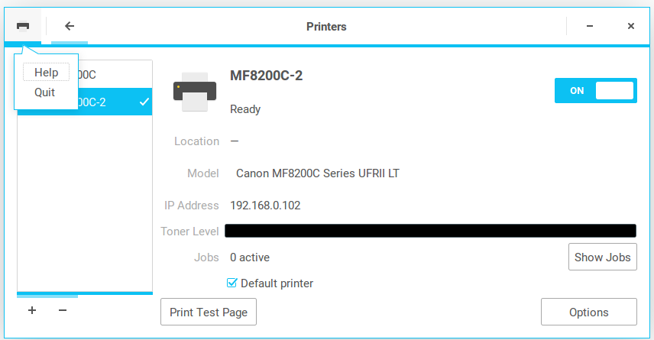

Additional notes from Dr. Abraham. Windows XP does not take much RAM space, so if you have limited RAM in your computer, you can install several instances of XP virtual machines to do the labs.

Recently I installed windows XP on VirtualBox. XP is really small and some of you having limited memory this is a good option. I overcame few challenges installing XP.

1. To install, it is better to download an XP image, make sure you have a valid windows product key.  Most image providers will also give you a product key that works. I installed it from Bootable Win XP disk that I already have; but, I had to add the CDROM device first, then mount and install.

2. Make sure your host machine (or let's call it the server), has a folder shared to everyone.  Also enable the feature for SMB 1.X.

3. I placed 32 bit program disk in The CDROM drive and shared it.  I was able to access it from the XP Virtual machine and install the program.  All worked well.

4. Could not browse the net, as the current browsers would not work on xp.  I downloaded  MyPal browser for win XP.  Installed it and all is working well.