**Final Exam 2017 Fall**

**Dr. Abraham**

**Please bring ScanTron form 30423 with your name and id bubbled in already.**

Study notes (20%), ppt slides (14%), student presentation questions (5%), and the multiple choice questions you have been working on (60%). The following are the quizzes you need to review.

Review again. [1](http://highered.mheducation.com/sites/0073376043/student_view0/chapter_03_-_multiple_choice_quiz.html) [2](http://highered.mheducation.com/sites/0073376043/student_view0/chapter_04_-_multiple_choice_quiz.html)

Quiz III [1](http://highered.mheducation.com/sites/0073376043/student_view0/chapter_10_-_multiple_choice_quiz.html) [2](http://highered.mheducation.com/sites/0073376043/student_view0/chapter_06_-_multiple_choice_quiz.html) [3](http://highered.mheducation.com/sites/0073376043/student_view0/chapter_07_-_multiple_choice_quiz.html) [4](http://highered.mheducation.com/sites/0073376043/student_view0/chapter_08_-_multiple_choice_quiz.html) due 11/5

Quiz IV [1](http://highered.mheducation.com/sites/0073376043/student_view0/chapter_13_-_multiple_choice_quiz.html) [2](http://highered.mheducation.com/sites/0073376043/student_view0/chapter_09_-_multiple_choice_quiz.html) [3](http://highered.mheducation.com/sites/0073376043/student_view0/chapter_14_-_multiple_choice_quiz.html) [4](http://highered.mheducation.com/sites/0073376043/student_view0/chapter_15_-_multiple_choice_quiz.html) 11/12

Quiz V [1](http://highered.mheducation.com/sites/0073376043/student_view0/chapter_03_-_multiple_choice_quiz.html) [2](http://highered.mheducation.com/sites/0073376043/student_view0/chapter_11_-_multiple_choice_quiz.html) [3](http://highered.mheducation.com/sites/0073376043/student_view0/chapter_24_-_multiple_choice_quiz.html) [4](http://highered.mheducation.com/sites/0073376043/student_view0/chapter_29_-_multiple_choice_quiz.html) 11/29

Quiz vi [1](http://highered.mheducation.com/sites/0073376043/student_view0/chapter_18_-_multiple_choice_quiz.html) [2](http://highered.mheducation.com/sites/0073376043/student_view0/chapter_19_-_multiple_choice_quiz.html) [3](http://highered.mheducation.com/sites/0073376043/student_view0/chapter_26_-_multiple_choice_quiz.html) [4](http://highered.mheducation.com/sites/0073376043/student_view0/chapter_26_-_multiple_choice_quiz.html) 12/6

Here are some highlights of the second half of the semester.

1. forwarding module of router, static and dynamic routing tables, how many tables for classful.
2. Classful and classless addressing schemes, calculate first and last ID, available IPs (total IPs), and mask calculations including default masks for classful.
3. netID, host ID calculations. Logical and physical address, protocols for obtaining one using the other.
4. direct and indirect delivery, node to node vs. process to process delivery.
5. How to determine the class based on first few bits, how would you extract those bits?
6. Quite a few questions from fragmentation based on MTU. Header and data length calculations, byte number based on offset values (first byte and last byte in a fragment), TTL, byte Numbering for a stream oriented connection.
7. ARP, ICMP, UDP, TCP, SYN flooding, denial of service, ACK , RWIND,
8. RIP, BOOTP, Distance Vector, BGP, IGP, EGP, AS, split horizon, silly window, source quench

**Review**

|  |  |  |
| --- | --- | --- |
| HLEN  TTL – maximum hop counts, hop count to restrict to the LAN.  Encapsulation  Packet  Frame  Datagram  ICMP  SSID  Error Messages – ICMP messages of various types and number associated with them  DHCP, BOOTP, RARP  Logical and physical addresses  Total length, header length, data length  Ping  Traceroute  TCP, UDP | TCP/IP layers  Distance Vector  RIP problems  Dynamic IP  DNS  ARP  VPN  Digital Certificates  Firwall – Packet filtering and Proxy  BGP  RIP  OSPF  MPLS  ATM  Special IP addresses: Network address, directed broadcast address, limited broadcast address, this computer, and loopback addresss. | Replay  Buffer overflow  Address spoofing  SYN flood  Phishing  Denial of service  Router configuration. CISCO IOS  Piggybacking  Distance Vector – route discovery & message intervals  Split horizon  EGRP  NAT  Assembly and Reassembly of Packets  Shortest Path computation  Longest prefix match  Default Routes  VLAN  Bridge |

Security Question: If Alice wants to send Bob an encrypted message using asymmetric Key how it done? How would it differ from a symmetric key encryption? What is digital signature? Ho could Alice be sure that a message was sent by Bob?

A packet with 4000 bytes needs to be sent. Fragmentation is allowed. It first passes through a network with a MTU of 1400, later it travels through a network with a MTU of 800. Show the fragments formed in the first network, and show the second fragment from this one being fragmented as it travels through the second network. I am looking specifically for Header length, Total Length, fragmentation flags, and fragment offset fields. Also show the byte numbers in each fragment. Also, explain how reassembly takes place.

Compare and contrast physical vs. IP address schemes. Make sure to include: (a) How these addresses are assigned, (b) Under which layer in which each layer operate, (c) How an unknown destination address is discovered (what protocols or servers are used), (d) One of these addresses can be divided into two parts, what are they and how can these parts be isolated?

Differentiate between a hub, repeater, bridge, switch and a router. Discuss the layers each operate under, which header each is capable of inspecting, and applicable use for each.

Several methods of gaining access to the media (MAC layer responsibility) were described in class. Explain the most common one. Explain static allocation models and collision free protocols.

Explain ARP and RARP protocols. Why are they used?

Explain sliding windows as related to TCP how it is used to control flow rate. Discuss IGRP and EGRP, and differentiate between RIP and OSPF.

Discuss how NAT aids in security associated with a Firewall.

Explain how the port numbers are used by UDP and TCP and why they are used. Also explain the difference between passive and active opens.

Alice sends a digitally signed document to Fred. Describe the process of digital signature and how Alice can’t repudiate. If she wants to send the signed document securely, how can that be done?

What is the difference between symmetric and asymmetric encryption? Describe appropriate uses for both. List some of the technologies and protocols used for both.

Summarize your practical project in less than 2 pages.

Explain failover clustering and describe how it was set up.

**Problems**

A packet has arrived with M bit value of 1 and fragmentation offset is zero. Is this first, middle or last fragment? Explain. What if the offset was 100, what would be the first byte number (from the original whole packet) in this fragment? Explain.

An IP datagram arrived with the following in the header (HEX – I ADDED THE SPACE FOR CLARITY):

45 00 00 54 00 03 00 00 20 06 00 00 7C 4E 03 02 B4 0E 0F 02

You will be asked all sorts of questions regarding this.

Using the following diagram, create a routing table for R1, R2 and R3

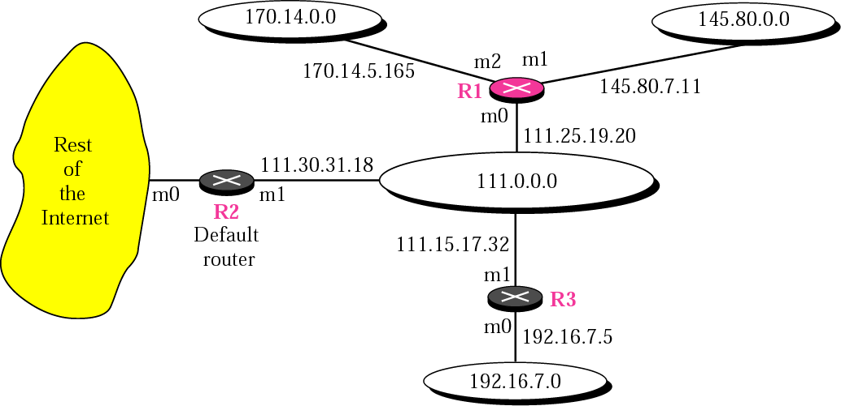

Given a CIDR address, find the first usable address and netmask.

Given a classfull network address and organizational requirements, make subnets and subnet masks. Example question: A class C address was given to your company. You have 4 departments with approximately equal number of computers and printers with a total of 100 devices requiring IP addresses. Make a subnet and explain your reasoning.

UTPA is given a class B IP address: 129.113.0.0. The computer science department requires 312 IP addresses. Create a CIDR address to hand to the computer science department. What would be subnet mask for a classfull address?