Assignment #4 Due November 19,2013

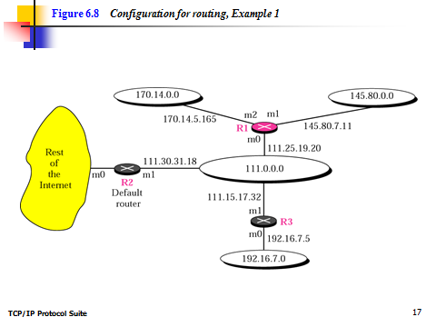

***Figure 6.9 shows the three tables used by router R1. Note that some entries in the next-hop address column are empty because in these cases, the destination is in the same network to which the router is connected (direct delivery). In these cases, the next-hop address used by ARP is simply the destination address of the packet.***

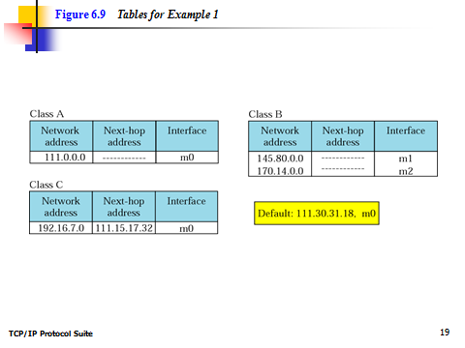

***Question Number 1:***

***Router R1 in Figure 6.8 receives a packet with destination address 192.16.7.14. Show how the packet is forwarded.***

***Question #2:***

***Router R1 in Figure 6.8 receives a packet with destination address 167.24.160.5. Show how the packet is forwarded.***

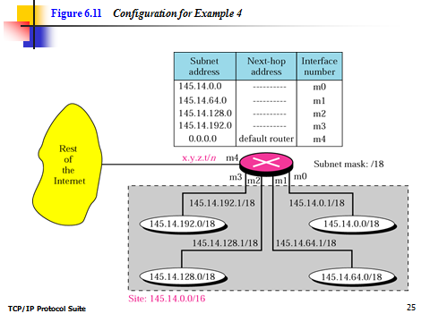

Question #3.

***The router in Figure 6.11 receives a packet with destination address 145.14.32.78. Show how the packet is forwarded.***

Question #4

***A host in network 145.14.0.0 in Figure 6.11 has a packet to send to the host with address 7.22.67.91. Show how the packet is routed***

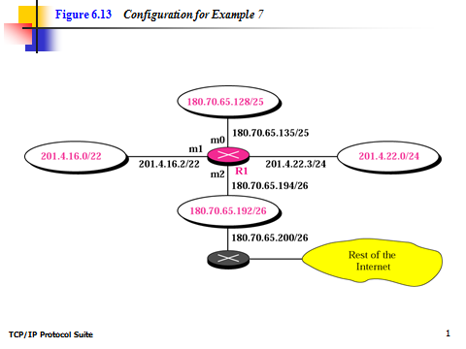

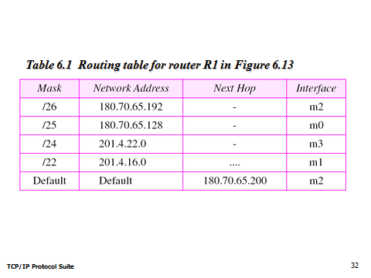

Question #5

***Show the forwarding process if a packet arrives at R1 in Figure 6.13 with the destination address 180.70.65.140.***

Question #6

***Show the forwarding process if a packet arrives at R1 in Figure 6.13 with the destination address 201.4.22.35***