C# Assignment #1
CSCI 3328
Dr. Abraham

You need to Chapters 1 and 2 in your textbook as a part of this assignment.
Due date: September 1, 2010. (Wednesday).

Please submit your assignments in a manila folder showing your name, assignment number and due date. Submit the program code and screen capture of program run.

1. Write a program to say hello using console environment in C#.

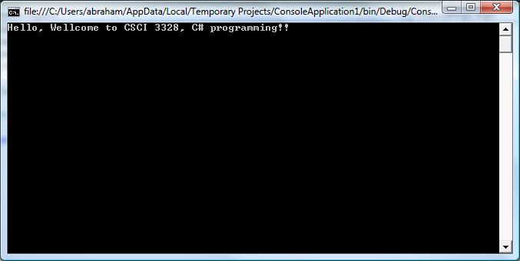
2. This assignment will introduce to the visual environment of Microsoft C#. Create a program to produce the following output.

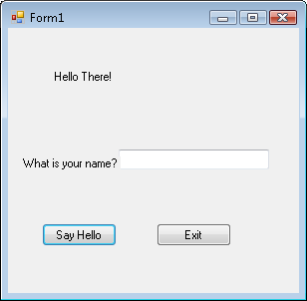

After the input:
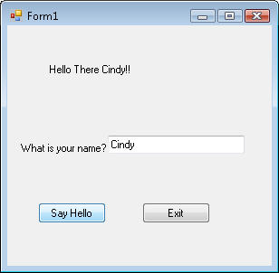

Press exit to quit the program

