CSCI 3328 C#
Programming Assignment 5
Dr. Abraham

The purpose of this assignment is for you to become fluent in manipulating arrays. Please store the numbers and deviation from mean and deviation squared in arrays. There are other simpler ways to calculate standard deviation. However, I expect you to follow this formula and create arrays as I suggested. This assignment is due on October 11, 2010.

Write a program to read numbers, entered as a text stream delimited by space, into an array and calculate standard deviation on the set of numbers. Here is the formula for standard deviation:

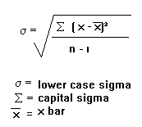
Lower case sigma means 'standard deviation'.
Capital sigma means 'the sum of'.
x bar means 'the mean'

Here is a program run:

