CSCI 3328 c#
Dr. Abraham

Programming Assignment 2
Due date: Sept 13, 2010

Write a program to find number of thousands, hundreds, tens and ones in a given integer. The results should be displayed in label boxes. Add an exit button and save button. Exit button should exit out of the program and the “Save” button should write the results to a file. The contents of the file are displayed in the screen capture shown below.

Submit source code, program runs, directory listing showing file created, and a print out of the file that was created.

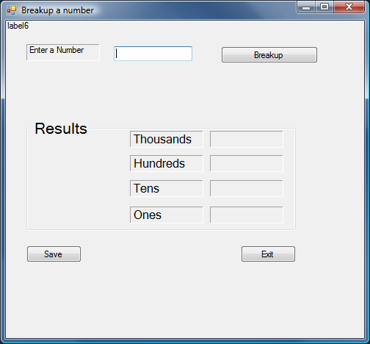

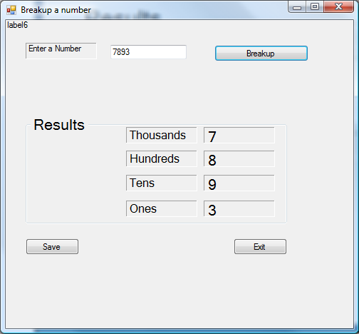

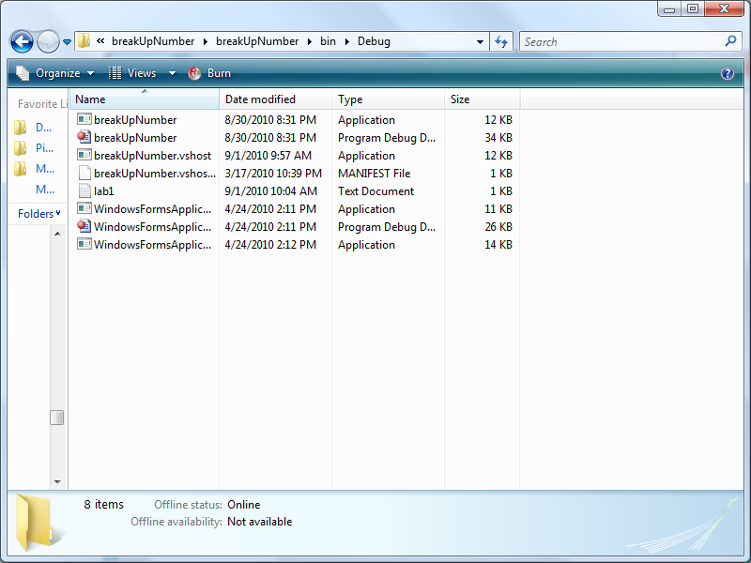
See lab1 with the date of 9/1/2010

