CSCI 3328
Programming Assignment #9
Due date – Dec 1, 2010

Purpose of this assignment:
- Work with files
- implement exception handling
- implement Stringbuilder
- Work with Tabs
- Implement sorting and binary searching
- Implement LINQ queries

Add tabs, exception handling , stringbuilder and binary search to Assignment #8. Here are some screen captures of the program run.

1. Reading the file
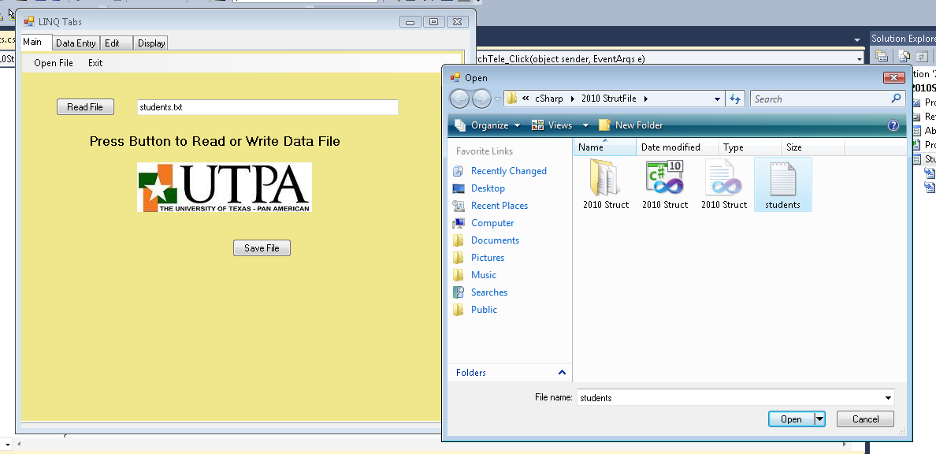

- The display tab shows what was read in.
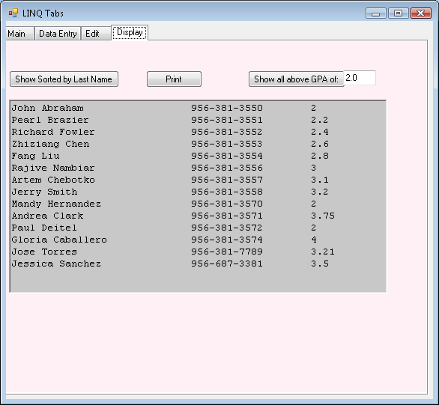

3. Adding a record under the Data Entry tab. Here I added 2 records, Sam Abraham and Philip Abraham

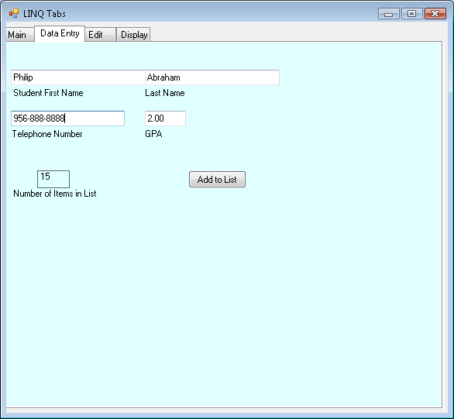

4.Editing a record using the Edit Tab. 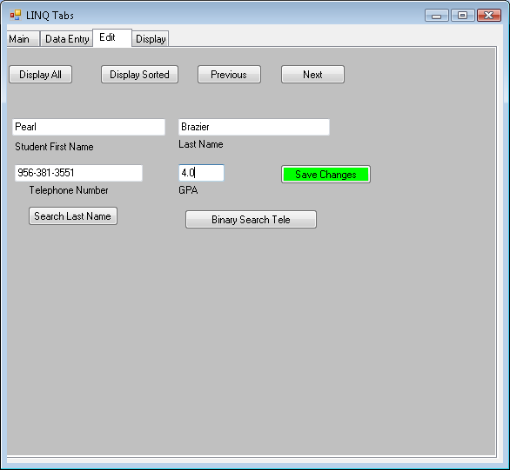I changed gpa of Brazier to 4.0

- Using display All, and pressing the Next or previous keys displays all records, one at a time. Previous and Next buttons are Active or Inactive depending on if it is first or last item.

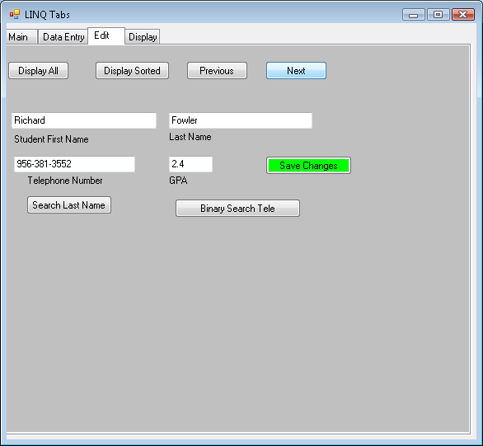

- Search for last name Abraham, should display all 3 Abrahams Entered, one at a time
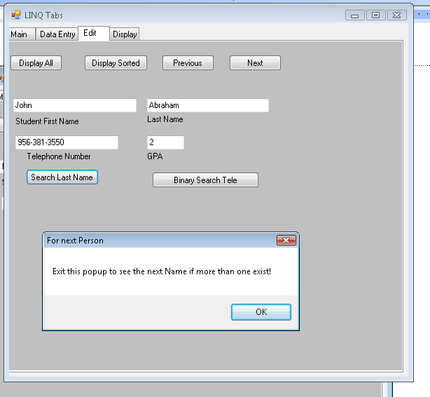

- Binary Search for 956-999-9999. To do this, implement your own bubble sort and binary search routine.

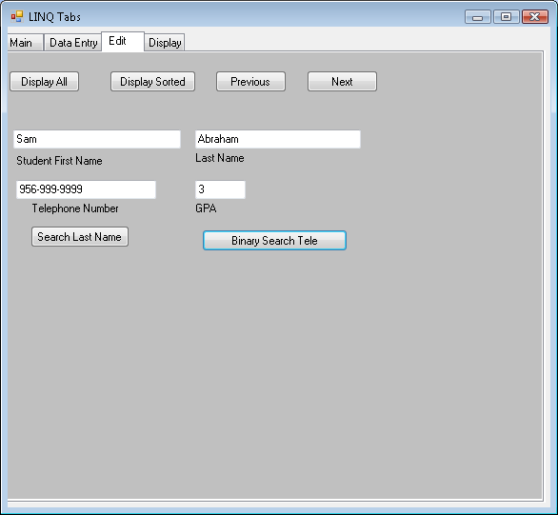
- Using LINQ query show all student made above a certain GPA and display it in the display tab.

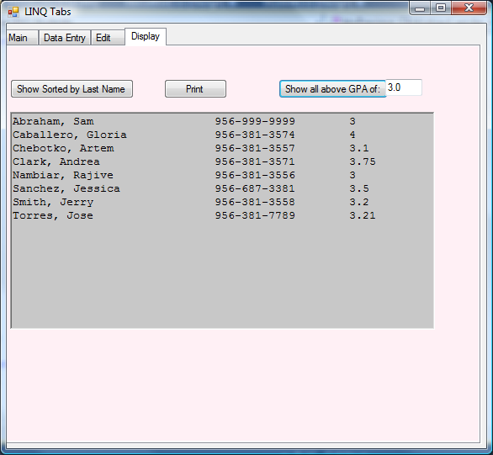

- Show sorted by last name. I added two names at the end, Jerry Mathews and Jim Edwards. It is sorted and listed below:
