Assignment 8
CSCI 3328
Dr. Abraham
Due Date (no exceptions): Nov 15, 2010

Purpose: Learn how to work with dropdown menus, work with Struct, Read from a textfile, and use LINQ.

Write a program to hold records of students that contains Last Name, First Name, Telephone Number, and GPA. You may want to modify it to add additional information, or make it a usable program for you to use in the future. But, get my approval first. Create searches based on different criteria.

Here is an example of a program run.

Clicked on Choose file to get the screen shot on the right. That gave the popup below: (if the file does exist, you need to create a textfile first).
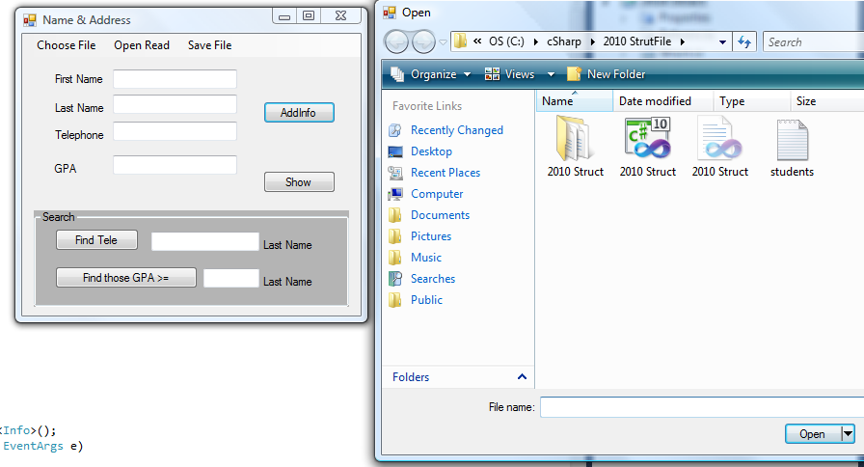

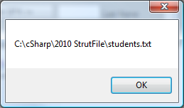

Clicked on Open & Read which gave a series of pop-ups like this:

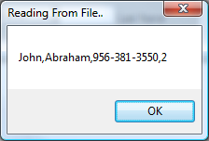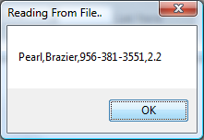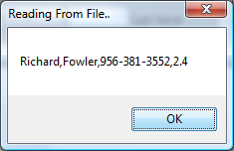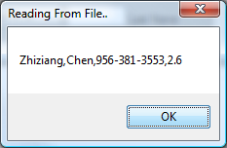

Click on show to give the following window:
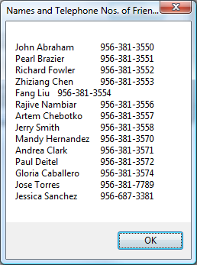

Now I added one more Abraham, (Sam Abraham) so the search will yield two names and clicked on AddInfo. Then Typed in Abraham in the search area and clicked on Find Tele.

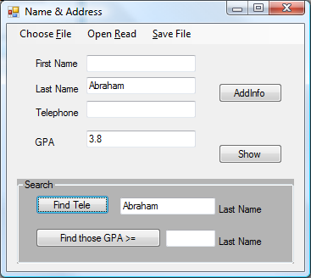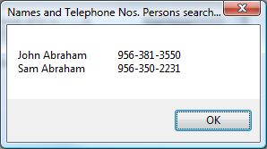

In the next screen I searched for GPA:
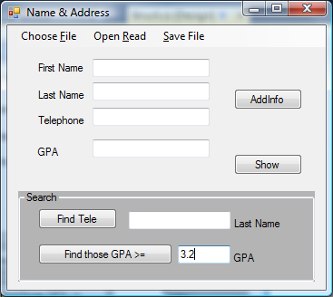
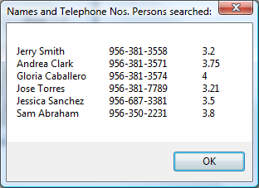

Finally, click on Save File so that all names you added will be saved to a file.

