Assignment #7
Postfix
Dr. Abraham
As per your request the due date is: Nov 8

In a conventional arithmetic expression, the operator is between the operands (2 + 3); this is called infix notation. Computers prefer postfix notation in which the operator is written to the right of its operands. A compiler would have to convert the infix to a postfix. Consider the following problems:

Infix | Postfix
(6.2 + 3) * 5 – 8 / 4 | 6.2 3 + 5 * 8 4 / -
(3 + 4) * 5 | 3 4 + 5 *
3 + 4 * 5 | 3 4 5 * +

Write a program to:
Accept a Postfix problem as a string (a number could be real or integer).
Parse the string to find the operands and opcodes
Opcodes allowed are: +, - , * , /
Using a stack data structure (that you create as a class) do the calculation. You may use array based or list based stack.
Display all activities in a dialog box.
Display the result in a label box.
Also show the stack visually. Use popup message boxes to explain all activities.

Explanation:
We evaluate the expression by scanning from left to right. Consider the problem
6 2 / 5 +. Look for the first operator beginning from left. The division operator is
applied to the immediate previous operands. The divisor would be the later one,
in this case 2. Now the problem has been reduced to 3 5 +. Continue processing until the end of the problem statement.

* this description and the samples are taken from Nell Dale's Book.

postfix expression | result
4 5 7 2 + - * | -16
3 4 + 2 * 7 / | 2
5 7 + 6 2 - * | 48

Here is a program run: (some screen shots have been omitted to save space.)
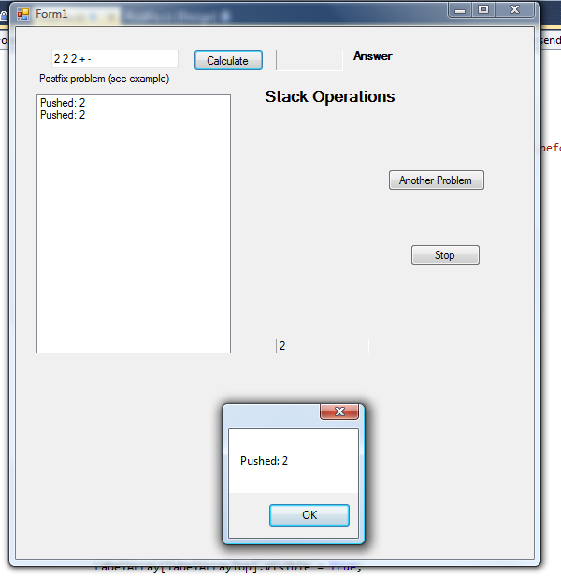
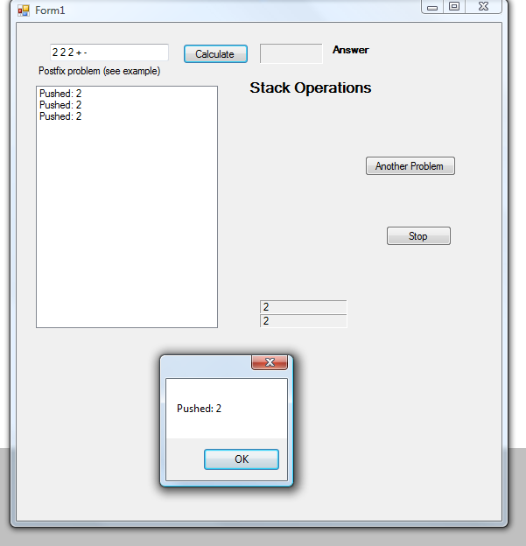

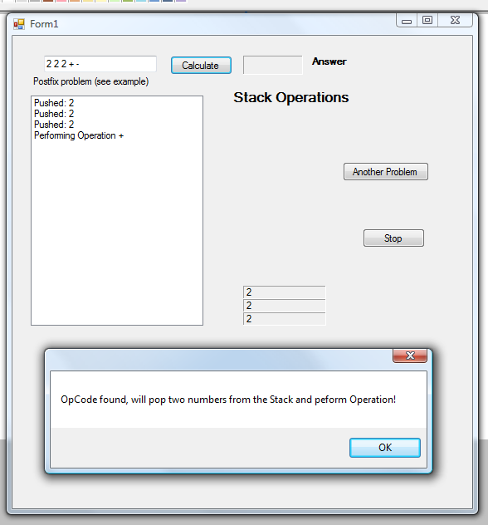
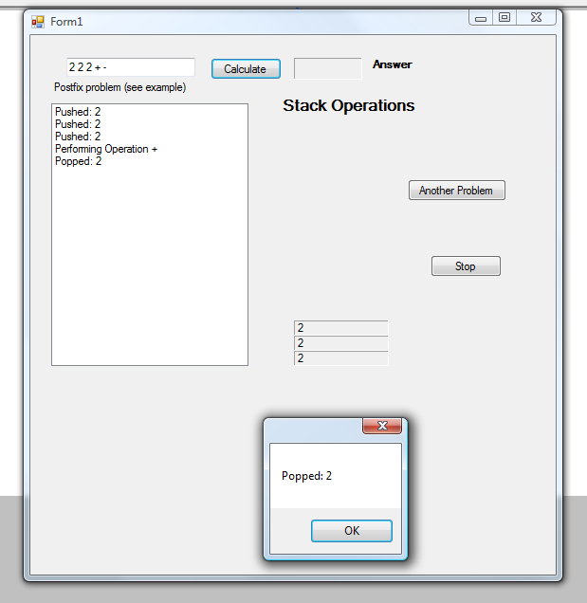
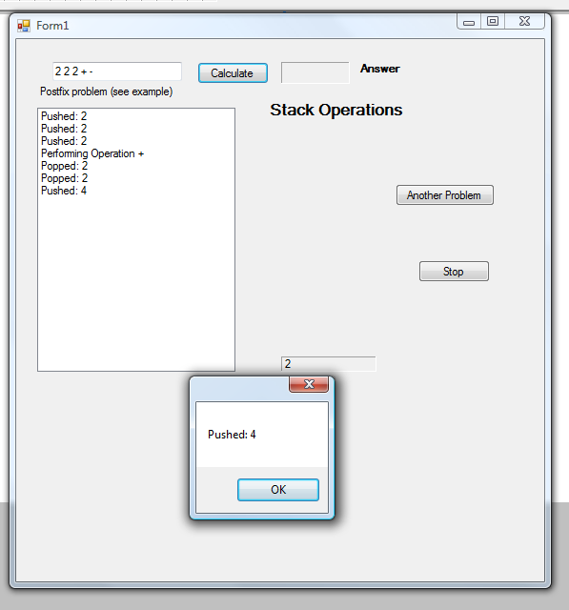
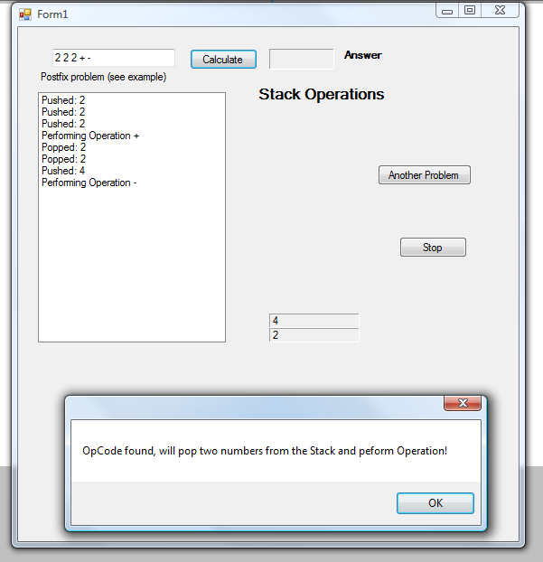
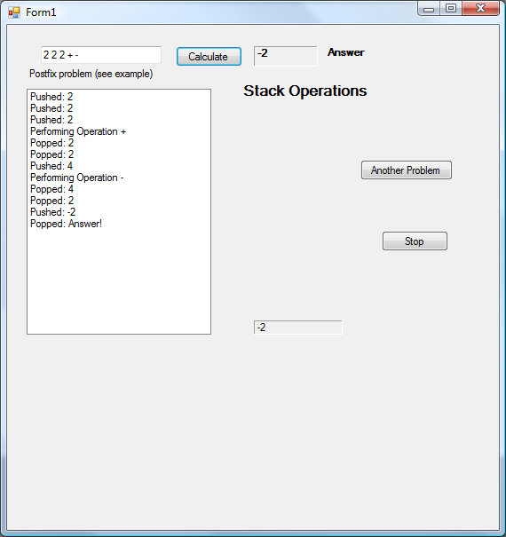

Another Program run showing just the last screen:
