SEQUENTIAL FILE PROCESSING

Objective: file input dialog, file output dialog, sequential file processing, and Sorting and searching techniques.

Note: You will need to use portions of this program for several of the upcoming programs. Please do not fall behind.

Assignment:

Write a program to create, add, sort and look up a customer information file. You may use a parallel array or an array of records. Here are selected views from a run.

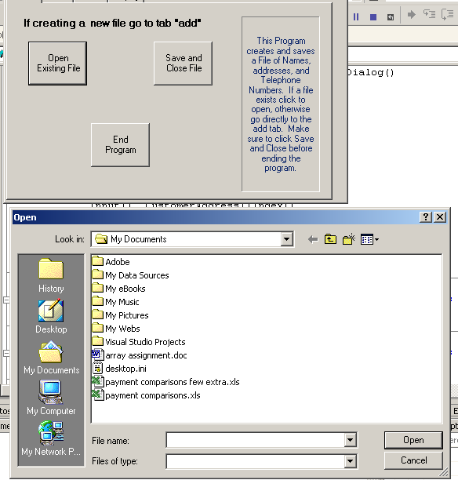
Or do it this way

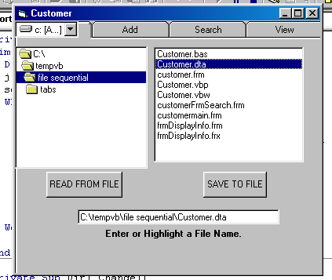

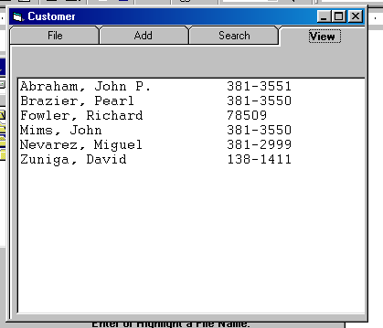

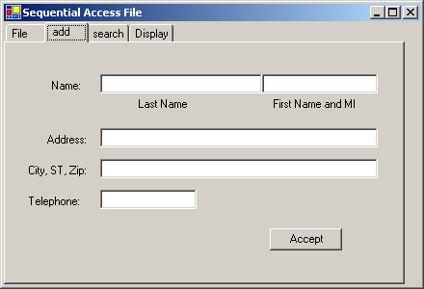

You only need to do one of the binary searches.

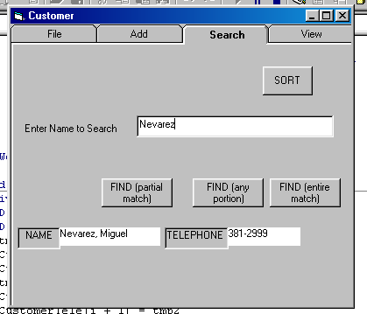
The following is after add and the sort.
