Assignment #4
CSCI 3327 VB.NET
Dr. Abraham

Write a program involving a single and two-dim arrays, shuffling and two-dim sorting as shown in the following samples. I have shown graphics version at the end.

Button Get New Deck: The card names are read from a file and displayed in a list box.

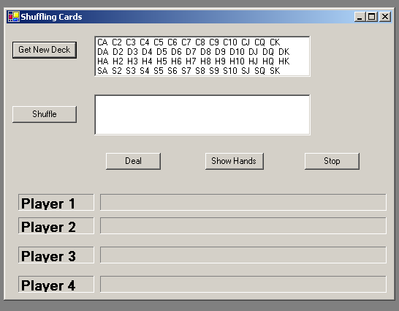

Button Shuffle: The cards are shuffled (abstractly) and displayed in the list box shown here.

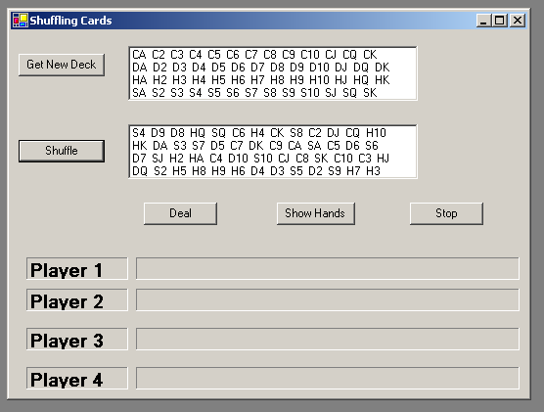

Button Deal: The shuffled cards are distributed one at a time in a round robin fashion to four players. Players cards are displayed in the appropriate 3D label boxes.

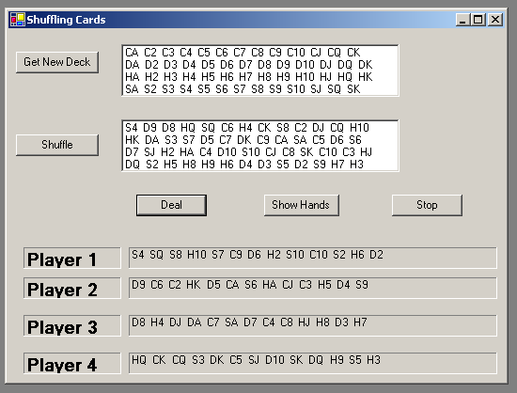

Button Show Hands: A new form is displayed with players cards.
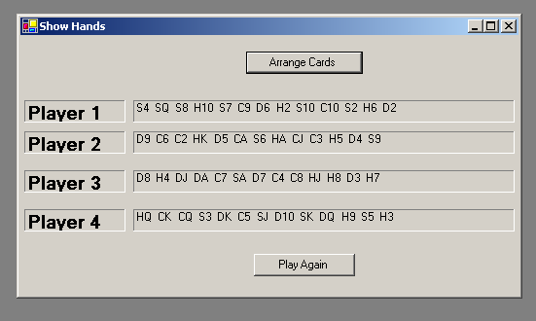

Button Arrange Cards: The cards are re-ordered using a two-dim sort and re-displayed.
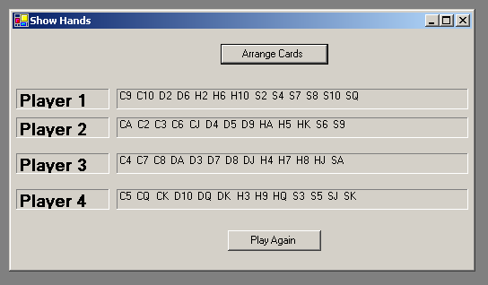

Button Play Again: This button takes you back to the previous form.

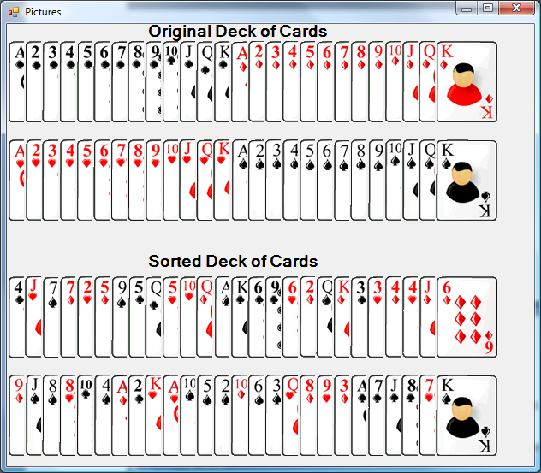

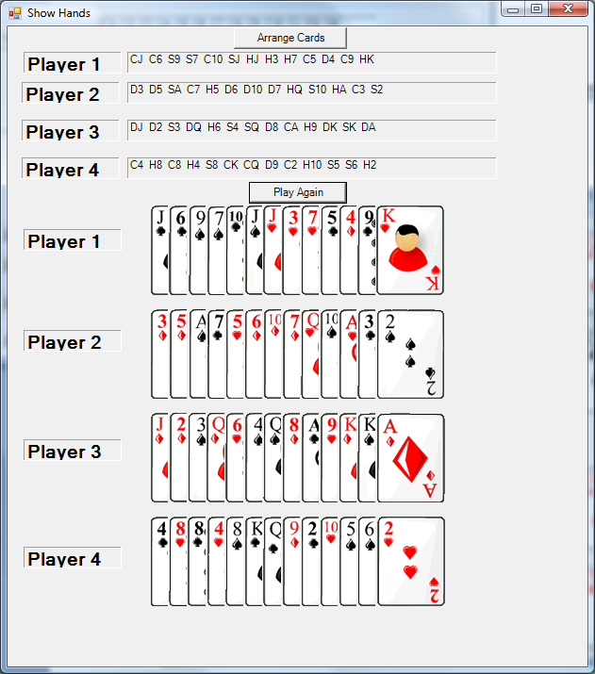

Arranged cards:

