ASSIGNMENT #9
FILE HANDLING AND INDEXING
VISUAL BASIC .NET

Write a program to create a random access file. Create and index with a key field and implement lookup using binary search on the index. The program should allow random retrieval of records, and modification of records. Attached are screen shots.

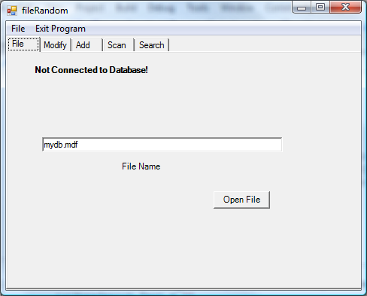

Open File:
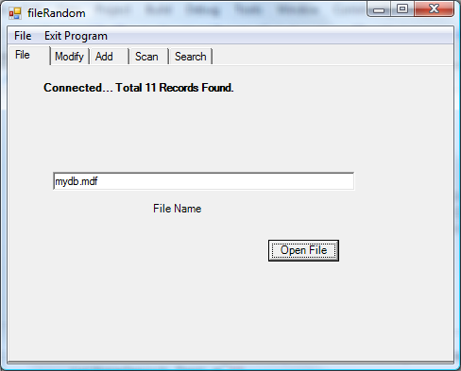

Get 4th record, under Modify tab
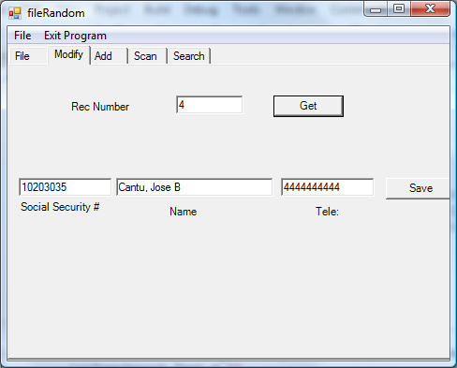

Add Tab (adds to the end of the file, here 12th record)
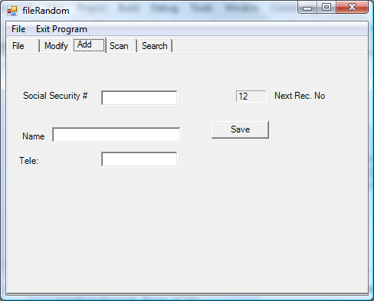

Scan tab (sequential access of file)
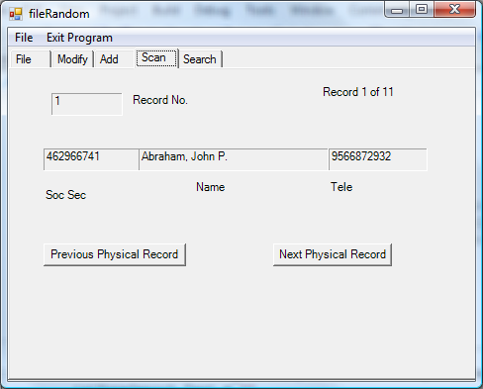

Search with linear search:
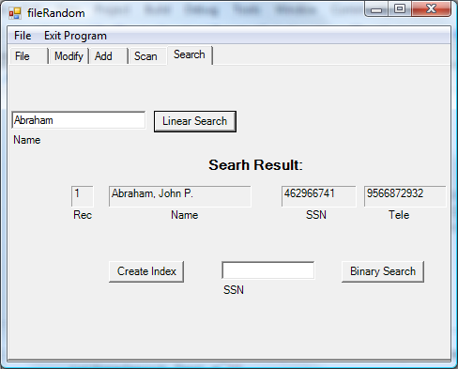

Create Index with SS#
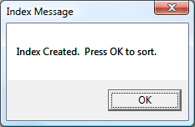

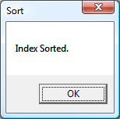

Binary Look up based on ss#
