**CSCI 1380**

**Lab Assignment 8**

**Dr. Abraham**

**Due date 3/30/2014**

Write a program to calculate standard deviation for a set of scores.

1. You need to create a file containing the scores.
2. The program should read the scores from the file.
3. Must code the following formula to calculate standard deviation.

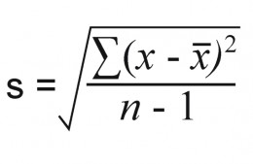

1. Display a table showing the score, its deviation from the mean, squared deviation, sum of all squared deviations, and finally the standard deviation.

Stadard Deviation for 8 Scores. Mean: 87.125

-----------------------------------------------------------

Score Dev Dev Sq Sum of dev2)

-----------------------------------------------------------

88 0.88 0.77 0.77

89 1.88 3.52 4.28

88 0.88 0.77 5.05

78 -9.13 83.27 88.31

89 1.88 3.52 91.83

90 2.88 8.27 100.09

91 3.88 15.02 115.11

84 -3.13 9.77 124.88

-----------------------------------------------------------

Standard Deviation 4.22