Lab Assignment #2

CSCI 1380

Dr. Abraham/Nicholas Hinojosa

**Modify the program you wrote for Lab Assignment #1, to include an outfile and send your inputs and outputs to that file. Print contents of that file and submit along with your source code.**

**This assignment is due on January 31, 2014**

**--------------------- Lab assignment 1 is given below---------------------------------------------**

In an electrical circuit, a current is generated if voltage is applied across one or more resistances. Write a program to calculate Current (amps) in a parallel circuit, given values of three resistors and voltage applied.

The Ohm’s law states I = V/R, where I = current in amperes, V = voltage in volts,

and R is the total resistance in the circuit).

Since there are three resistors in this parallel circuit, figure out how to find the total resistance. The total resistance of a set of resistors in parallel is found by

adding up the reciprocals of the resistance values and then taking the reciprocal of the total.

Due date: January 24th, 2014

What to submit: Source Code, algorithm and Program Run (Screen Capture is acceptable for this lab).   
Please follow instructions given by Mr. Hinojosa as to how to submit, either electronically or in a folder.

Please note: Please write the entire code in the main function. We will be covering how to write functions in a few days.

Here is a sample run:

Enter applied Voltage: 24

Enter three resistance values in ohms:100

200

300

Total resistance is: 54.5455 ohms

Current is: 0.44 Amps!

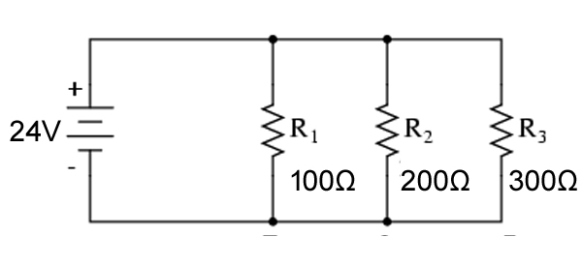

**Formula to find total resistance in a parallel circuit**

$$R_{total}= \frac{1}{\frac{1}{R_{1}}+ \frac{1}{R_{2}}+\frac{1}{R_{3}}} 54.5455Ω= \frac{1}{\frac{1}{100Ω}+ \frac{1}{200Ω}+\frac{1}{300Ω}}$$

-----------------------------------------Here an example of a program development-----------------------

**Sample only**

**Write a program to calculate the area and perimeter of a circle**

**These are the three steps required for software development:**

**1.** •Step 1 - Analyze the problem

−Outline the problem and its requirements

−Design steps (algorithm) to solve the problem

•Thoroughly understand the problem

For each radius entered calculate area and perimeter.

The programmer needs to know the formula for calculating these

results.

The programmer needs to know the that PI is a constant and its

value.

•Understand problem requirements

−Does program require user interaction?

Yes, it requires for the user to enter the radius.

−Does program manipulate data?

Yes, it does the following calculations:

perimeter = 2 * radius * PI

area = radius * radius * PI

−What is the output?

The output are the results, perimeter and area.

**The algorithm is:**

1. Get the radius of the circle

2. Calculate the perimeter using the equation

perimeter = 2 * radius * PI

3. Calculate the area using the equation

area = radius * radius * PI

4. Print out the perimeter and area

•Step 2 - Implement the algorithm

−Implement the algorithm in code

−Verify that the algorithm works

I will demonstrate this in class. Please do not copy the code. You need to

write the code yourself.

•Step 3 - Maintenance

−Use and modify the program if the problem domain changes