Assignment Kickoff
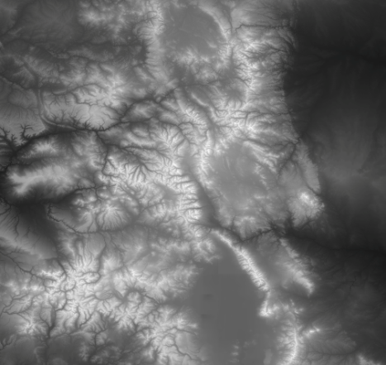
You are given 2-dimensional elevation data for a map region (a 2D array of height values). Your caravan can enter the region at any point on the left side, and exit at any point on the right side. As you traverse the region, you’re going to have to step up or down from position to position.
Assuming that the entry and exit points are all equally good, how would you find the easiest (least total elevation change) path from one side of the map to the other?
What if your goal was to minimize moving up but not down? Or to stay as high as possible? Or to avoid steep drops? How would that change your approach?

